Tershula Kriya

July 14, 1992 — N/A— Espanola, NM

http://www.libraryofteachings.com/lecture.xqy?q=Trishula%20sort:relevance&id=e0a948b1-c72b-5f10-536c-872557c6316c&title=KWTC---Lecture

Version 1 of 1

Total Meditation Time: not practiced in class. Given as 11 minute, 31 minute or 62 minute options

Video Time: explained from 1:23:15 – 1:29:38
1 - Part Meditation

“Tershula will put three gunas together, Tamas, Sattvik and Rajvas…It is Har, Har, Wahe Guru and you have three guna, Tamas, Sattvik and Rajvas they all three are controlled, one is your imperial way, ambitious way, ruling way that is Rajvas, Tamas is your angry way to get thing and Sattvik is your saintly way, so you have only three ways to go through and it totally fixes it up. Har, Har, Har, Wahe Guru. There are five words in it Har, Har, Wahe Guru, because five tattvas have to support three gunas and it does work right there.”

PART 1: 11 minutes, 31 minutes or 62 minutes
Mudra Shown in Video: 1:23:15 Video Time (1:23:15 – 1:29:38)
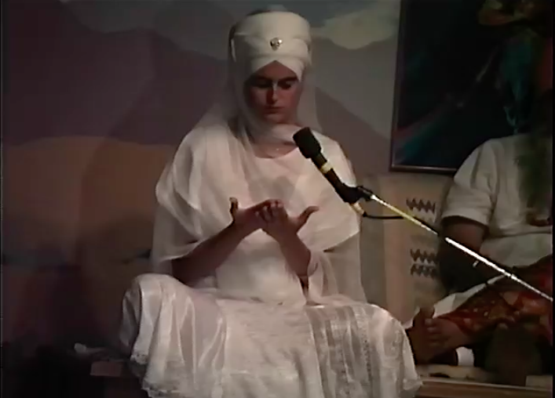
Posture/Mudra: Sit straight easy pose. Place the right palm over left, fingers tight together, thumbs out so that the hands form a trident. Elbows rest on the ribcage and the hands should be in a straight line from the elbows to the fingertips i.e. no bend in the wrists. The angle of the arms is 45 degrees in front of the body, slightly in front of the heart.

Breath: Inhale deep, pulling the naval in. Hold the breath and concentrate on Har Har Wahe Guru as you visualize a blue light circling your hands. When you cannot hold the breath any longer, powerfully exhale through the nose and visualize blue fire going out from your finger tips as you keep the naval in and pull a little mulbhand.
Eyes: Closed. Focus straight ahead through the eyelids (no third eye and no tip of nose)
Mantra: Mentally focus on Har Har Wahe Guru.

Time: Meditation not practiced in class. Explanation given from 1:23:15 – 1:29:38
END: Not Specified in the Video.

